**Problem Statement:**

Bangalore's water crisis stems from unsustainable consumption, compounded by data scarcity hindering informed water management. BWSSB lacks granular real-time water usage data across sources (Cauvery, borewell, tanker), obstructing equitable distribution, conservation efforts, and accurate demand forecasting.

**Conceptual Solution: WiseWaters**

Implement a smart metering network using Automated Meter Reading (AMR) technology. Strategically install AMR meters at:

* **Borewells**
* **Cauvery supply lines**
* **Overhead tank outputs**

Tanker water usage is uniquely calculated by subtracting the sum of Cauvery and borewell readings from the overall tank consumption.

AMR data is integrated with BWSSB accounts for every residence and commercial establishment, providing precise monthly consumption figures for each water source.

**Data-Driven Action**

* **LPCD Benchmarking:** Compare individual water usage against WHO-recommended Liters Per Capita Day (LPCD) standards.
* **Tiered Tariffs:** Households significantly exceeding LPCD thresholds (e.g., YELLOW for 15% excess, RED for 25%+) face higher water tariffs to strongly incentivize conservation.
* **Empowerment:** Consumers gain actionable insights to reduce usage, while BWSSB acquires vital data for demand forecasting, equitable allocation, and sustainable water planning.

**Beneficial Impact:**

* **Reduced Water Deficit:** Aim to significantly reduce Bangalore's substantial water deficit by promoting responsible consumption and addressing equitable distribution in alignment with 150 LPCD WHO guidance.
* **Conservation Incentives:** Tiered pricing based on accurate data drives water-saving behavior.
* **Efficient Resource Management:** BWSSB gains the tools to precisely forecast water demand, optimizing allocation and future planning for a sustainable urban water system.

**Challenges & Risks:**

* **Consumer Resistance:** Potential pushback to higher tariffs and concerns over data privacy.
* **Technical Hurdles:** AMR installation and maintenance could pose reliability challenges.
* **Funding & Policy:** Significant upfront investment and strong policy support are crucial for success.

**Detailed Design:**

Here's a breakdown of a detailed technical design for the WiseWaters solution, keeping in mind that specifics may need adjustment based on BWSSB's existing infrastructure and chosen technology providers:

**I. Hardware Components**

* **AMR Meters:**
  + **Type:** Likely electromagnetic meters for their precision, especially for bulk and Cauvery water measurements. Consider ultrasonic for potential leak detection benefits. Mechanical with AMR upgrades may be used for last-mile residential connections.
  + **Quantity:** Determined by a thorough survey of metering points (borewells, overhead tanks, major Cauvery supply lines).
* **Data Collectors/Concentrators:**
  + **Type:** Depends on transmission technology. RF-based systems will need collectors strategically placed throughout Bangalore to receive meter readings.
  + **Placement:** Density depends on the range of the RF technology used and existing infrastructure for mounting.
* **Network Gateway:** A central point to aggregate data received from collectors/concentrators. May be integrated with BWSSB's existing IT systems.

**II. Communication Technology**

* **Meter-to-Collector:**
  + **Radio Frequency (RF)** is most common. License-exempt frequency bands (around 900MHz) typically used. Requires careful frequency planning to avoid interference.
  + **Cellular:** Possible for remote meters or enhanced security. Adds cost due to cellular data plans.
* **Collector-to-Gateway:**
  + **Wired:** Ethernet or fiber if collectors have access to existing wired infrastructure
  + **Cellular:** More flexible, ideal if collectors don't have fixed line access.

**III. Software Components**

* **Central Data Management System (CDMS):** Core of the solution.
  + **Meter Data Management:** Collects, stores, processes AMR meter readings.
  + **Account Integration:** Securely links meter data to individual BWSSB consumer accounts.
  + **LPCD Calculation:** Calculates monthly LPCD for each account based on household size, etc.
  + **Tiered Tariff Logic:** Applies tariff rules based on LPCD exceedance thresholds.
  + **Analytics & Reporting:** Data dashboards, usage reports for consumers, planning insights for BWSSB.
* **Consumer-Facing App/Web Portal:**
  + **Usage Visualization:** Clear graphs/charts showing historical use by water source.
  + **LPCD Tracking:** Display current LPCD vs. WHO standards.
  + **Conservation Tips:** Personalized recommendations to reduce water usage.

**IV. Security**

* **Data Encryption:** At rest and in transit, using robust standards (e.g., AES-256).
* **Access Controls:** Role-based access, strict authentication for CDMS and consumer portals.
* **Audit Trails:** Maintain logs of system access and changes for accountability.
* **Privacy:** Clear privacy policy outlining data collection, use, with opt-out options where possible.

**V. System Rollout**

* **Pilot Phase:** Test technology, processes in a limited area before city-wide deployment.
* **Prioritization:** Target areas with high water stress or existing metering points first.
* **Technical Support:** Robust installation and maintenance teams, helpdesk for consumers/BWSSB staff.
* **Consumer Awareness:** Public campaigns to explain benefits, address concerns, and promote participation.

**Additional Considerations**

* **Integration with Billing Systems:** Ensure smooth flow of consumption/tariff data into BWSSB's billing processes.
* **Scalability:** Design with Bangalore's growth in mind.
* **Open Standards:** Where possible, use open protocols to promote vendor choice and future flexibility.

**Important Note:** This is a high-level design. Collaboration between BWSSB, a specialist technology vendor, and water management consultants would be essential for precise specifications, infrastructure assessments, and successful implementation.

**Technology Stack:**

Here's a possible technology stack for implementing the WiseWaters solution, along with some rationales for the choices:

**I. Hardware**

* **AMR Meters:**
  + Vendors like Badger Meter, Itron, Kamstrup, Arad provide a range of AMR-enabled electromagnetic and ultrasonic meters.
  + Consider factors like accuracy, communication options (RF, cellular), and integration ease with chosen software.
* **Data Collectors/Concentrators:**
  + If RF-based, vendors tied to meter vendors are often available (e.g., Itron, Kamstrup).
  + Ensure compatibility with the frequency and data protocols the meters use.
* **Network Gateway:**
  + A capable Linux server may suffice if data volumes are moderate.
  + Cloud-based gateways (AWS IoT Core, Azure IoT Hub) provide scalability if data volumes are very large.

**II. Software**

* **Central Data Management System (CDMS):**
  + **Backend:** Python (Django/Flask) or Java (Spring Boot) are robust choices for the backend logic, API layer, and data processing.
  + **Database:** PostgreSQL for structured data, potentially with a time-series optimized database like InfluxDB for efficient storage of meter readings.
  + **Deployment:** Linux servers (physical or cloud-based VMs) are standard. Containerization (Docker) is ideal for flexibility and scaling.
* **Consumer App/Web Portal:**
  + **Frontend:** React, Angular, or Vue.js for modern, interactive interfaces.
  + **Backend:** Node.js with Express for a lightweight API layer.
* **Security:**
  + **Standard Practices:** Follow OWASP guidelines.
  + **Frameworks/Tools:** Consider Django/Spring security features, third-party auth providers (Auth0, Okta), encryption libraries, web application firewalls (WAFs)

**III. Cloud Services (Optional but Highly Recommended)**

* **Cloud Hosting:** AWS, Azure, or Google Cloud provide flexible infrastructure options (servers, databases, etc.). Benefit from scalability and managed services.
* **IoT Platforms:** These platforms can simplify device management, data ingestion, and analytics if metering systems are large-scale (e.g., AWS IoT, Azure IoT Hub).
* **Data Visualization:** Tools like PowerBI, Tableau, or open-source Grafana for dashboarding and reporting.

**IV. Additional Considerations**

* **Billing Integration:** Explore APIs or data exchange mechanisms provided by BWSSB's existing billing software.
* **GIS Integration:** Potential to visualize meter locations and usage patterns on maps using ArcGIS, QGIS, or Leaflet.
* **Machine Learning:** In the future, for water demand forecasting and anomaly detection (leak identification).

**Technology Selection Philosophy**

* **Balance:** A mix of well-established technologies (e.g., Python, PostgreSQL) with modern tooling (React, cloud services) for performance and maintainability.
* **Open Source:** Where possible, to favor flexibility and avoid vendor lock-in.
* **Scalability:** Cloud-native architecture allows the solution to grow with Bangalore's needs.
* **Security as a Focus:** Security considerations integrated from the start, not as an afterthought.

**Important Note:** Market solutions specifically for smart water management exist. BWSSB should thoroughly evaluate off-the-shelf products alongside a custom-built approach to find the best fit for their requirements.

**Implementation Plan:**

Here's a breakdown of a potential implementation plan for the WiseWaters solution, along with very rough effort estimations and schedule. Please note, these are highly dependent on the scale of deployment, specific technology choices, and BWSSB's resources:

**Project Phases**

1. **Planning & Procurement**
   * **Detailed Requirements Gathering:** Thorough technical specifications in collaboration with BWSSB and stakeholders.
   * **Technology Vendor Selection:** RFP process, evaluation of meters, software solutions, and potential service providers.
   * **Project Plan & Resource Allocation:** Timeline, team structure, budget.
   * **Estimated Effort:** 30-50 person-days
   * **Timeline:** 2-3 months
2. **Pilot Deployment**
   * **Target Area Selection:** Limited geographic area for initial testing.
   * **Meter Installation:** Physical installation of AMR meters at chosen points.
   * **Software Setup & Integration:** CDMS configuration, initial consumer portal development, test billing integration.
   * **Monitoring & Feedback:** Collect data, consumer reactions, and system performance metrics.
   * **Estimated Effort:** 50-100 person-days (heavily dependent on pilot area size)
   * **Timeline:** 3-4 months
3. **City-wide Rollout (Phased)**
   * **Prioritization:** Divide Bangalore into zones based on water stress, infrastructure, etc.
   * **Scaled Meter Procurement & Installation:** Based on the pilot experience.
   * **CDMS Scaling:** Enhance the system to handle a larger data volume and user base.
   * **Consumer Awareness Campaigns:** Public education, addressing concerns in each zone.
   * **Estimated Effort:** Highly variable. Likely hundreds of person-days over multiple phases.
   * **Timeline:** Could span 1-2 years depending on the deployment pace.
4. **Ongoing Operations & Optimization**
   * **System Monitoring & Maintenance:** Meter health, software updates, security patches.
   * **Data Analysis & Insights:** Support BWSSB's decision-making with detailed reports.
   * **Consumer App Enhancements:** New features based on feedback.
   * **Predictive Analytics (Future):** Develop leak detection, demand forecasting models.

**Effort Estimation Caveats:**

* **Assumptions:** This assumes some existing IT infrastructure at BWSSB and the use of partially off-the-shelf components. A fully bespoke solution would require significantly more development effort.
* **Team Composition:** Requires a mix of water utility domain experts, software developers, network engineers, installation technicians, project managers, and consumer outreach personnel.
* **Unknowns:** Existing BWSSB system complexity, regulatory hurdles, and vendor procurement times all introduce uncertainties.

**Overall Timeline:**

A realistic timeline, even for a relatively small pilot, is likely around 6-9 months from initial planning to go-live. City-wide deployment could take years.

**Important:** This is a very high-level plan. Successful implementation demands a detailed project charter, risk assessment, change management, and close collaboration with BWSSB throughout the process.

**Solution Concept Diagram**

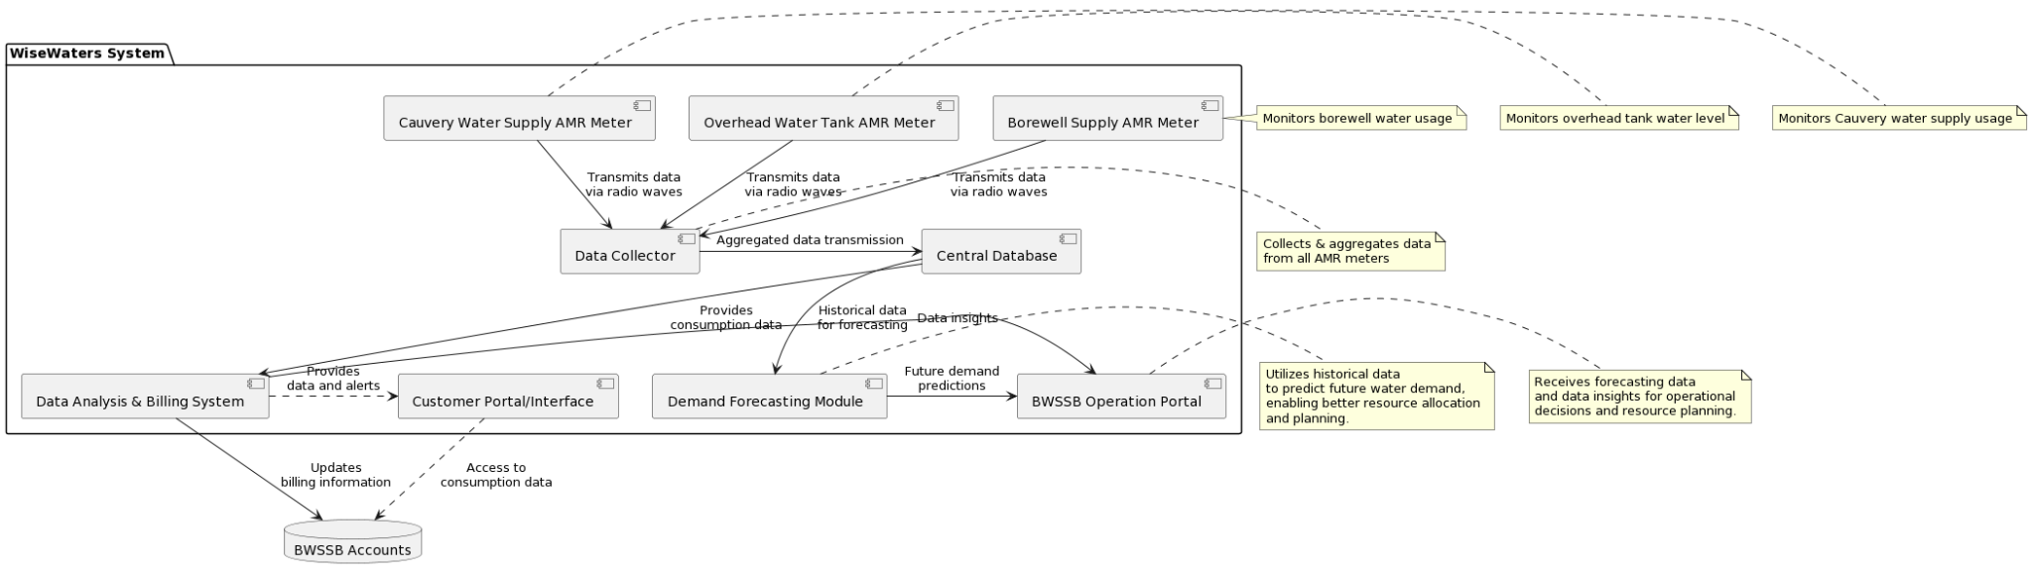

@startuml WiseWaters Technical Architecture with Data Collector

package "WiseWaters System" {

component [Borewell Supply AMR Meter] as BorewellAMR

component [Overhead Water Tank AMR Meter] as OverheadAMR

component [Cauvery Water Supply AMR Meter] as CauveryAMR

component [Data Collector] as DataCollector

component [Central Database] as Database

component [Data Analysis & Billing System] as AnalysisSystem

component [Customer Portal/Interface] as CustomerPortal

component [Demand Forecasting Module] as Forecasting

component [BWSSB Operation Portal] as OperationPortal

}

database "BWSSB Accounts" as BWSSBAccounts

BorewellAMR -down-> DataCollector : Transmits data\nvia radio waves

OverheadAMR -down-> DataCollector : Transmits data\nvia radio waves

CauveryAMR -down-> DataCollector : Transmits data\nvia radio waves

DataCollector -right-> Database : Aggregated data transmission

Database -down-> AnalysisSystem : Provides\nconsumption data

AnalysisSystem --> BWSSBAccounts : Updates\nbilling information

CustomerPortal .> BWSSBAccounts : Access to\nconsumption data

AnalysisSystem .> CustomerPortal : Provides\ndata and alerts

Database -down-> Forecasting : Historical data\nfor forecasting

Forecasting -right-> OperationPortal : Future demand\npredictions

AnalysisSystem -right-> OperationPortal : Data insights

note right of BorewellAMR : Monitors borewell water usage

note right of OverheadAMR : Monitors overhead tank water level

note right of CauveryAMR : Monitors Cauvery water supply usage

note right of DataCollector : Collects & aggregates data\nfrom all AMR meters

note right of Forecasting : Utilizes historical data\nto predict future water demand,\nenabling better resource allocation\nand planning.

note right of OperationPortal : Receives forecasting data\nand data insights for operational\ndecisions and resource planning.

@enduml

Functional Architecture:

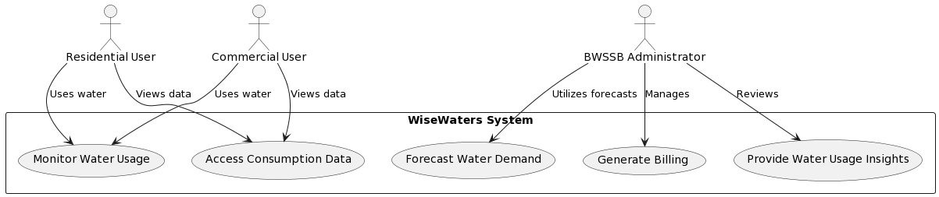

@startuml WiseWaters Functional Architecture

actor "Residential User" as Residential

actor "Commercial User" as Commercial

actor "BWSSB Administrator" as Admin

rectangle "WiseWaters System" {

usecase "Monitor Water Usage" as Monitor

usecase "Generate Billing" as Billing

usecase "Access Consumption Data" as AccessData

usecase "Provide Water Usage Insights" as Insights

usecase "Forecast Water Demand" as Forecast

}

Residential --> Monitor : Uses water

Residential --> AccessData : Views data

Commercial --> Monitor : Uses water

Commercial --> AccessData : Views data

Admin --> Billing : Manages

Admin --> Insights : Reviews

Admin --> Forecast : Utilizes forecasts

@enduml

Technical Architecture:

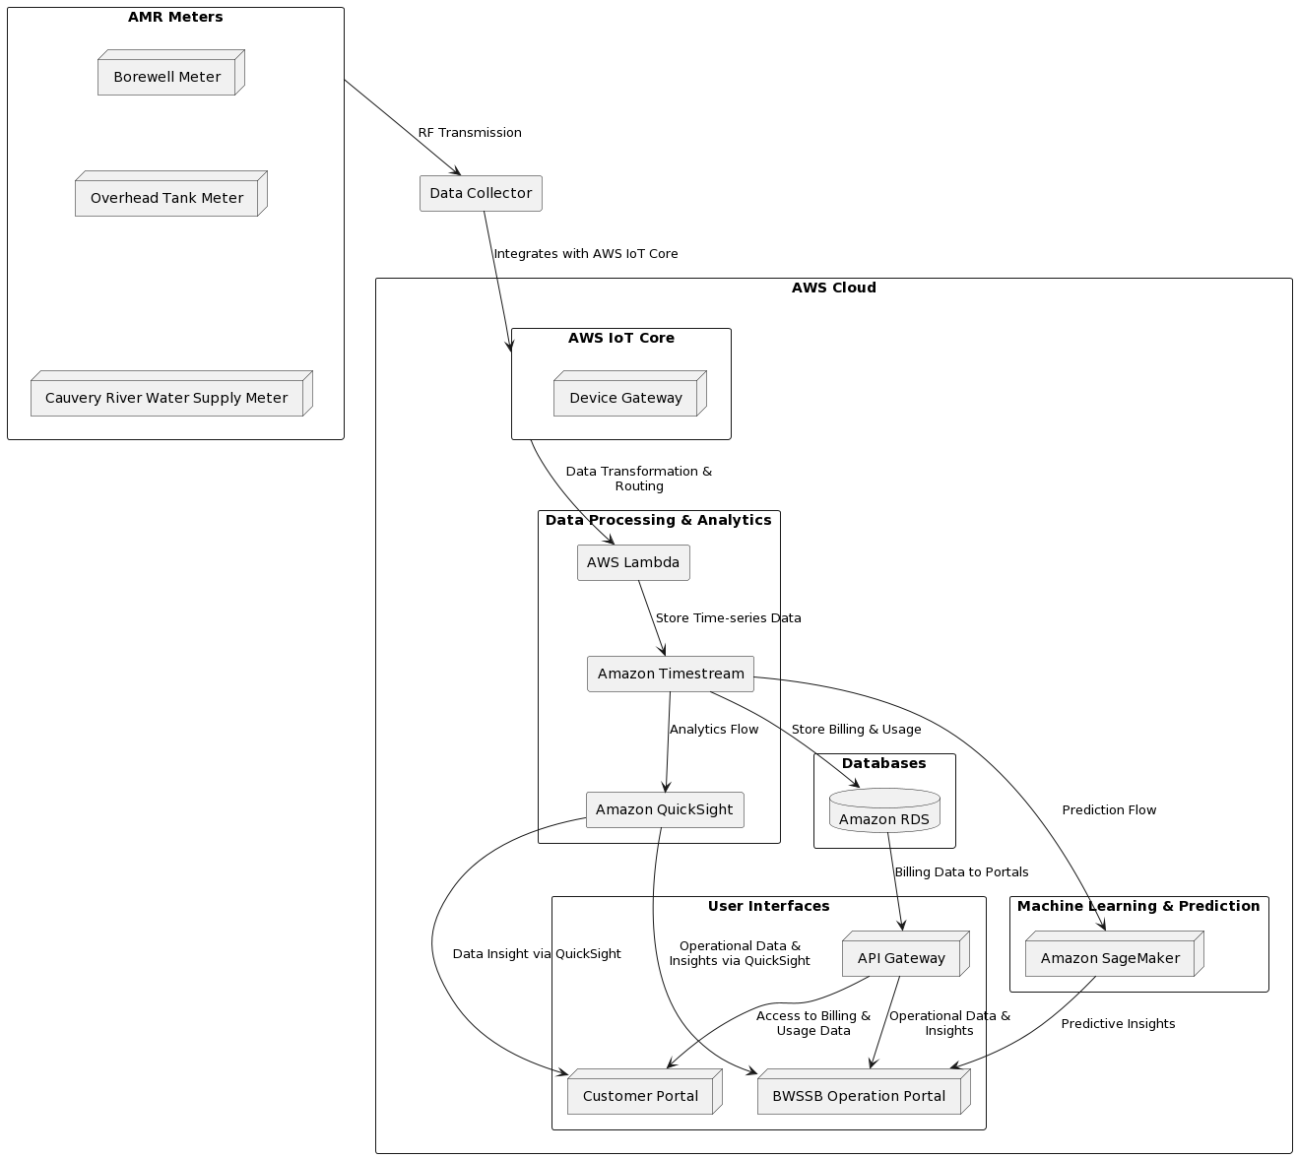

@startuml

rectangle "AWS Cloud" {

rectangle "AWS IoT Core" as IoTCore {

node "Device Gateway" as DeviceGateway

}

rectangle "Data Processing & Analytics" as Processing {

rectangle "AWS Lambda" as Lambda

rectangle "Amazon Timestream" as Timestream

rectangle "Amazon QuickSight" as QuickSight

}

rectangle "Databases" as Databases {

database "Amazon RDS" as RDS

}

rectangle "User Interfaces" as UI {

node "API Gateway" as APIGateway

node "Customer Portal" as CustomerPortal

node "BWSSB Operation Portal" as BWSSBOpPortal

}

rectangle "Machine Learning & Prediction" as ML {

node "Amazon SageMaker" as SageMaker

}

}

rectangle "Data Collector" as DataCollector

rectangle "AMR Meters" as AMRMeters {

node "Borewell Meter" as BorewellMeter

node "Overhead Tank Meter" as TankMeter

node "Cauvery River Water Supply Meter" as CauveryMeter

}

BorewellMeter -[hidden]-> TankMeter

TankMeter -[hidden]-> CauveryMeter

AMRMeters --> DataCollector : "RF Transmission"

DataCollector --> IoTCore : "Integrates with AWS IoT Core"

IoTCore --> Lambda : "Data Transformation &\nRouting"

Lambda --> Timestream : "Store Time-series Data"

Timestream --> QuickSight : "Analytics Flow"

QuickSight --> BWSSBOpPortal : "Operational Data &\nInsights via QuickSight"

QuickSight --> CustomerPortal : "Data Insight via QuickSight"

Timestream --> SageMaker : "Prediction Flow"

SageMaker --> BWSSBOpPortal : "Predictive Insights"

Timestream --> RDS : "Store Billing & Usage"

RDS --> APIGateway : "Billing Data to Portals"

APIGateway --> CustomerPortal : "Access to Billing &\nUsage Data"

APIGateway --> BWSSBOpPortal : "Operational Data &\nInsights"

@enduml

Latest implementation plan:

To implement the entire solution involving Amazon QuickSight and the integration of AMR meters for water usage monitoring and analysis, let's break down the project into key phases, estimate the effort in person-days, and propose a schedule for a pilot rollout. This solution will include IoT data capture, analytics, prediction, and billing/account management, alongside the integration into customer and BWSSB operation portals.

### Phase 1: Planning and Requirements Gathering

- **Tasks**: Define project scope, gather detailed requirements, select pilot area, and identify stakeholders.

- **Effort**: 5 person-days.

- **Schedule**: Week 1.

### Phase 2: Design and Architecture

- **Tasks**: Design the system architecture, including AWS services (IoT Core, Lambda, Timestream, RDS, QuickSight, API Gateway), data models, and integration workflows. Security and data privacy considerations.

- **Effort**: 10 person-days.

- **Schedule**: Week 2.

### Phase 3: AMR Meters Setup and IoT Integration

- **Tasks**: Procure and install AMR meters (borewell, overhead tank, Cauvery supply), set up data collectors, and integrate with AWS IoT Core.

- **Effort**: 15 person-days.

- **Schedule**: Weeks 3-4.

### Phase 4: Data Processing and Storage Implementation

- **Tasks**: Implement data ingestion (AWS Lambda), storage (Timestream for time-series data, RDS for billing/accounts), and establish basic monitoring.

- **Effort**: 20 person-days.

- **Schedule**: Weeks 5-6.

### Phase 5: Analytics and Prediction Setup

- **Tasks**: Configure Amazon QuickSight for analytics and dashboards, develop initial ML models with SageMaker for water usage prediction.

- **Effort**: 15 person-days.

- **Schedule**: Weeks 7-8.

### Phase 6: Portal Development and Integration

- **Tasks**: Develop customer and BWSSB operation portals, integrate with AWS backend (API Gateway, QuickSight embedding), and implement authentication mechanisms.

- **Effort**: 25 person-days.

- **Schedule**: Weeks 9-11.

### Phase 7: Testing and Quality Assurance

- **Tasks**: Conduct comprehensive testing (unit, integration, system, and user acceptance testing), including IoT device reliability, data accuracy, portal functionality, and user experience.

- **Effort**: 20 person-days.

- **Schedule**: Weeks 12-13.

### Phase 8: Training and Documentation

- **Tasks**: Prepare and deliver training sessions for BWSSB staff and key stakeholders, create user guides and technical documentation.

- **Effort**: 10 person-days.

- **Schedule**: Week 14.

### Phase 9: Pilot Rollout and Monitoring

- **Tasks**: Deploy the solution in the selected pilot area, monitor system performance, collect feedback from users and stakeholders.

- **Effort**: 15 person-days (ongoing support and monitoring).

- **Schedule**: Weeks 15-16.

### Total Estimated Effort

- **Approximate Total**: 135 person-days.

### Approximate Schedule for Pilot Rollout

- **Duration**: The pilot phase is scheduled over 16 weeks (~4 months) from planning to deployment and initial monitoring.

### Notes

- **Flexibility**: The schedule and effort estimates might need adjustments based on the actual scope discovered during planning, unforeseen technical challenges, and stakeholder feedback.

- **Team Composition**: The effort assumes a multidisciplinary team with skills in AWS services, IoT integration, data science, web development, and project management. The distribution of tasks may require adjusting based on the team's specific skills and availability.

- **Scaling Post-Pilot**: Based on the pilot's outcomes, the project will enter a review phase to address any issues, gather insights, and plan for a broader rollout, which will require additional scheduling and resources.

This plan provides a structured approach to deploying a pilot of the proposed water management solution, setting a foundation for scaling and further enhancements based on pilot outcomes and feedback.

Here is a table representation of the implementation plan for the pilot rollout of the water management solution involving Amazon QuickSight and other AWS services:

| **Phase** | **Description** | **Tasks** | **Effort (Person-Days)** | **Schedule (Weeks)** |
| --- | --- | --- | --- | --- |
| 1 | Planning and Requirements Gathering | Define project scope, gather requirements, select pilot area, identify stakeholders. | 5 | 1 |
| 2 | Design and Architecture | Design system architecture, data models, and integration workflows. Security and data privacy considerations. | 10 | 2 |
| 3 | AMR Meters Setup and IoT Integration | Procure/install AMR meters, set up data collectors, integrate with AWS IoT Core. | 15 | 3-4 |
| 4 | Data Processing and Storage Implementation | Implement data ingestion (Lambda), storage (Timestream, RDS), and monitoring. | 20 | 5-6 |
| 5 | Analytics and Prediction Setup | Configure QuickSight for analytics, develop ML models with SageMaker. | 15 | 7-8 |
| 6 | Portal Development and Integration | Develop customer and BWSSB portals, integrate with AWS backend, implement authentication. | 25 | 9-11 |
| 7 | Testing and Quality Assurance | Comprehensive testing (unit, integration, system, UAT), including IoT reliability and data accuracy. | 20 | 12-13 |
| 8 | Training and Documentation | Prepare/deliver training sessions, create user guides and technical documentation. | 10 | 14 |
| 9 | Pilot Rollout and Monitoring | Deploy in pilot area, monitor performance, collect feedback. | 15 (ongoing) | 15-16 |

Total Estimated Effort: 135 person-days.